CHMG 141 Recitation 3 Names:

**Puzzle #1 (4 pts)**

Fill in the missing numbers in the following table:

|  |  |  |  |  |  |
| --- | --- | --- | --- | --- | --- |
| Chemical  symbol | Atomic number | Number of protons | Number of neutrons | Number of electrons | Mass Number |
|  | 24 |  | 29 | 22 |  |
| 65Cu+ |  |  |  |  |  |
|  |  |  | 52 | 38 | 93 |
| 33S2- |  |  |  |  |  |

**Piece #1 (1/2 pt)** – I have 360 eggs. How many dozen eggs do I have?

**Piece #2 (1/2 pt)** – Each egg has a mass of 45 g. What is the mass of a dozen eggs?

**Piece #3 (1/2 pt)** I have 896 g of eggs. How many dozen eggs do I have? How many individual eggs do I have?

**Piece #4 (1/2 pt)** 6.022x1023 anythings make up 1 mole. I have 896 g of eggs. How many moles of eggs do I have?

**Puzzle #2 (2 pts)** Exactly1 mole of magnesium atoms has a mass of 24.301 g. If I have 500.0 g of magnesium, how many moles of magnesium do I have?

**Puzzle #3 (2 pt**) Water is a molecule made by assembling 2 hydrogen atoms (H) and 1 oxygen atom (O).

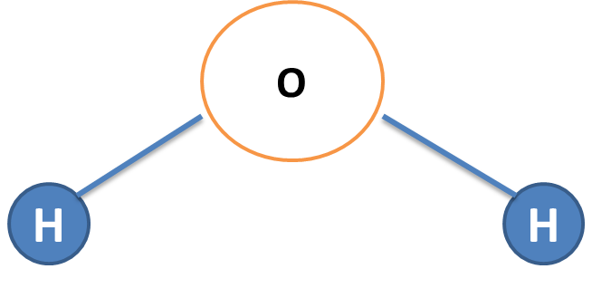

I have 0.35 moles of water molecules.

A) How many moles of hydrogen atoms are there in my water?

B) How many moles of oxygen atoms are there in my water?